GRIS – Detachment Inspection Checklist
Project:
Unit:
Remarks:

Position | Item | Potential Detachment Concern | Residual risk | Expected Qty | Pre-Test  Qty Verified | Pre-Test  Associated Control / Verification Point |  | Pre-Test  Remarks | Post-Test  Qty Verified
1 | Cover retaining screw | Backing out | Low | 8 |  | Torque mark aligned | ☐
 |  |  |  |  |  | Retention tape present and intact | ☐
 |  |  |  |  |  | No visible loosening or backing out | ☐
2 | Module joining shoulder screw | Backing out | Low | 8 |  | Torque level verified | ☐
3 | Extender retaining screw | Backing out | Very Low | 6 |  | Torque level verified | ☐
4 | ELCID magnetic sensor fastening screw | Backing out / Pull-out | Very Low | 2 |  | Torque level verified | ☐
5 | Motor cover screw | Backing out / Pull-out | Low | 8 |  | Torque mark aligned | ☐
 |  |  |  |  |  | Retention tape present and intact | ☐
6 | ELCID magnetic sensor | Fracture | Very Low | 2 |  | No visible damage or degradation | ☐
7 | Camera retaining screw | Backing out / Pull-out | Low | 10 |  | Torque mark aligned | ☐
8 | Gear cover | Fracture / Disengagement | Very Low | 2 |  | Fit fully seated | ☐
 |  |  |  |  |  | Retention tape present and intact | ☐
9 | Track belt | Derailment | Very Low | 2
10 | Recovery hook | Backing out / Pull-out | Very Low | 2 |  | Torque mark aligned | ☐
11 | Wheel axle shoulder screw | Backing out | Low | 6 |  | Torque mark aligned | ☐
12 | Main connector housing screw | Backing out | Very Low | 2 |  | Torque mark aligned | ☐
 |  |  |  |  |  | Retention tape present and intact | ☐
13 | Main connector latch screw | Backing out | Very Low | 2 |  | Mechanical retention engaged | ☐
14 | Bottom camera position locking screw | Backing out | Very Low | 2 |  | Mechanical retention engaged | ☐
15 | Central slot guide | Disengagement | Very Low | 2 |  | Fit fully seated | ☐
 |  |  |  |  |  | No movement or disengagement | ☐
16 | Leaf spring retaining screw | Backing out | Low | 2 |  | Torque mark aligned | ☐
 |  |  |  |  |  | No visible loosening or backing out | ☐
17 | Leaf spring | Fracture | Very Low | 1 |  | No cracks or permanent deformation | ☐
18 | Impactor grub screw | Backing out | Very Low | 2 |  | Retention tape present and intact | ☐
 |  |  |  |  |  | Light torque confirmation | ☐
19 | Track wheels | Fracture | Very Low | 6 |  | No visible damage or degradation | ☐
20 | Magnets retaining screw | Backing out | Low | 8 |  | Torque mark aligned | ☐
21 | Impact solenoid | Detachment | Very Low | 1 |  | Fully seated in mount | ☐
22 | Camera lens | Backing out | Very Low | 6 |  | No movement under light torque | ☐

Pre-Test Verification
Verified by:
Signature:
Date:

Post-Test Verification
Verified by:
Signature:
Date:
Position Identification
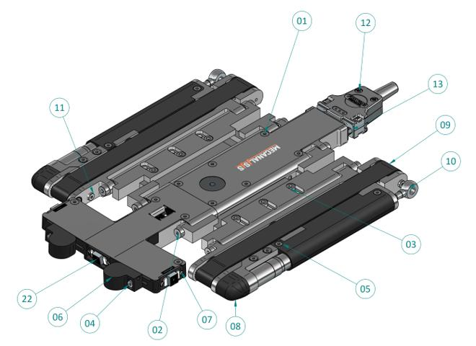
Figure 1. Position Identification - GRIS isometric top view
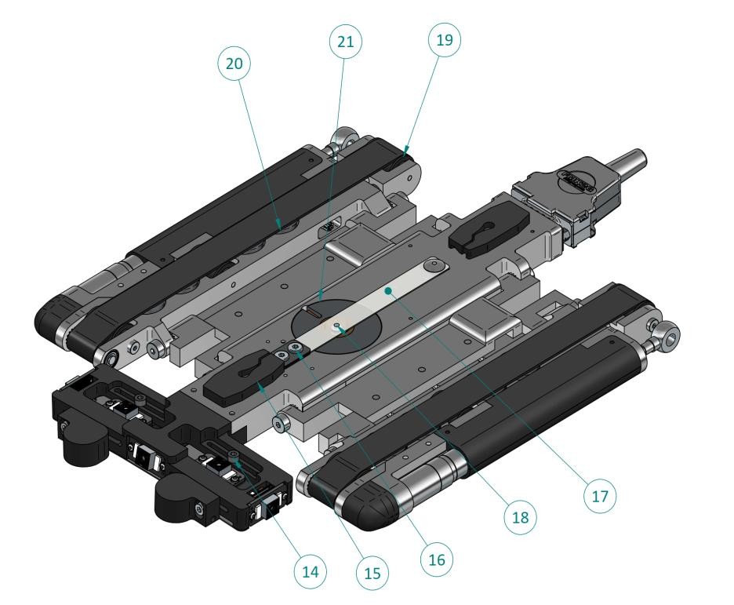
Figure 2. Position Identification - GRIS isometric bottom view

